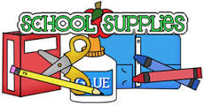

2nd Grade Supply List 2023-2024

Gibbs Elementary School

***All children will need headphones.***

-6 glue sticks  
-1 package of **sharpened Ticonderoga** pencils – *NO decorative pencils please*

-2 packages of cap erasers  
-1 pair of scissors (labeled with your child’s name)  
-3 – 24 count boxes of Crayola crayons  
-1 plastic pencil box (labeled with your child’s name)  
-1 -3 hole **clear** pencil pouch (this will go in notebook)  
-3 pkgs. of 4 **BLACK** Expo markers (more if possible)  
-1 inch 3 ring binder with **clear pocket on the front**-2 boxes of Kleenex

-1 package of colored highlighters

Girls – 1 package of red pens  
Boys – 1 package of Band-Aids

**Extra items that would be helpful**

Baby wipes  
Sandwich and gallon size baggies

Paper towels

Post it notes